1) Generate teh Testscript and feature file for Selenium Java

2) Change the logo and reload the extension

(manifest.json,config-appConfig.js)

AI Extension:

Converting images size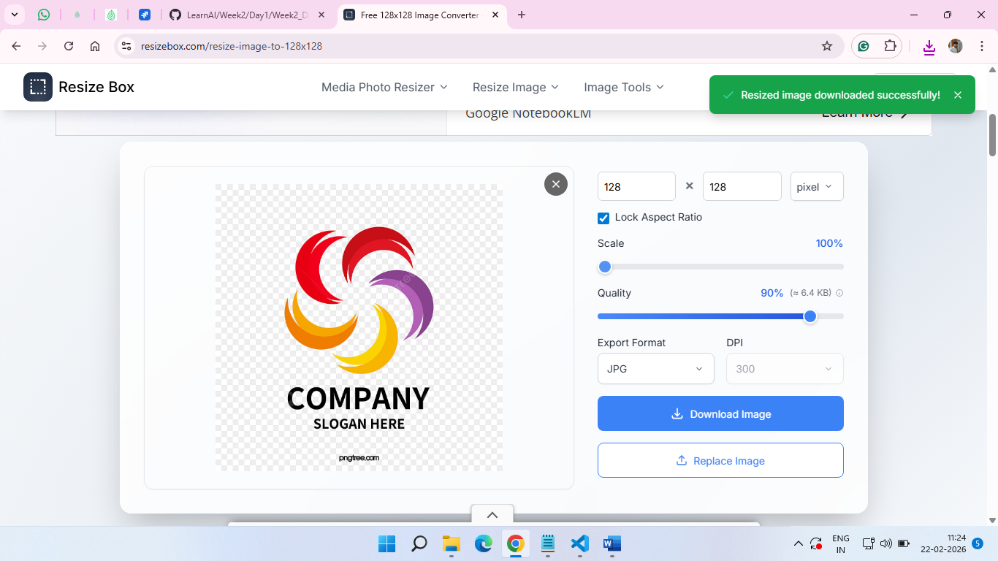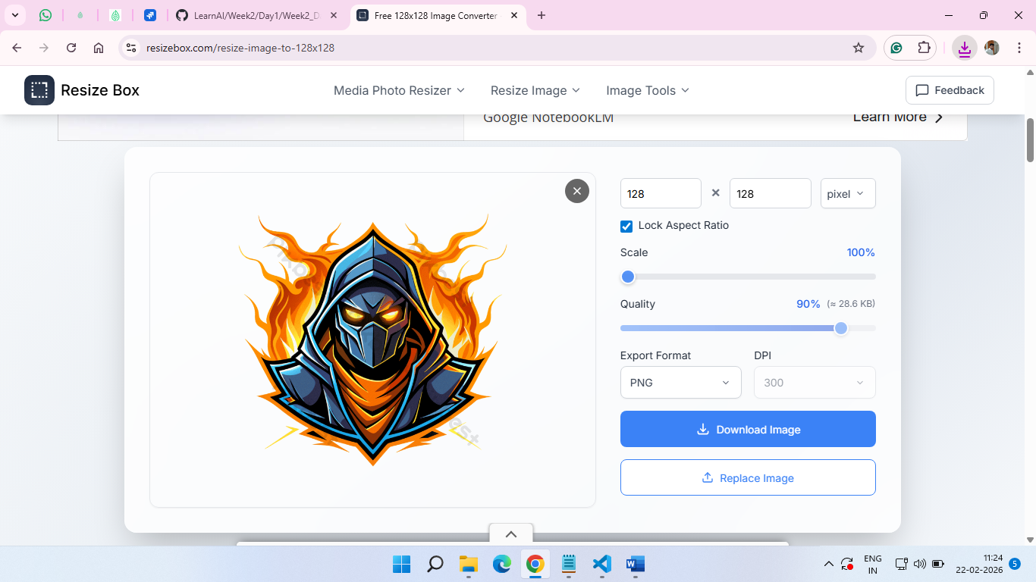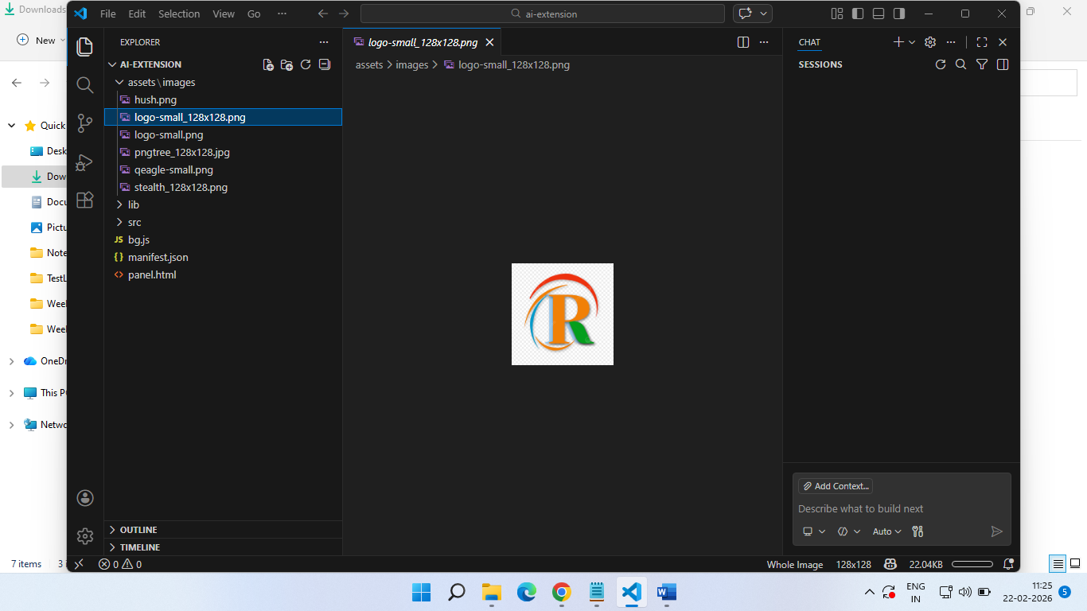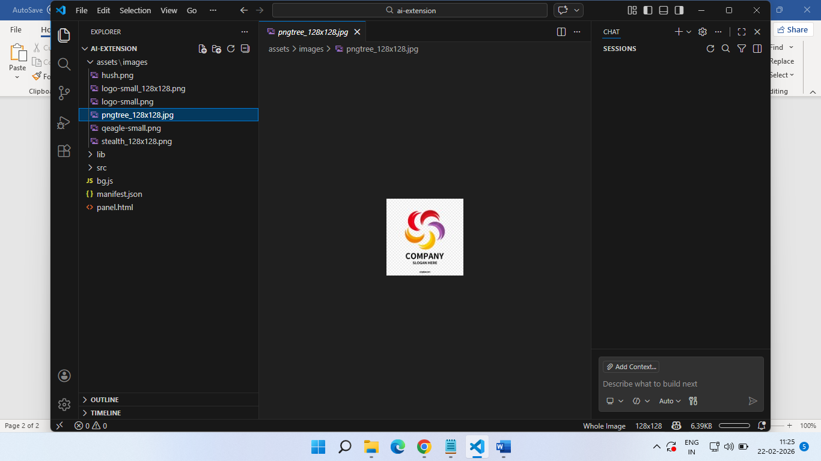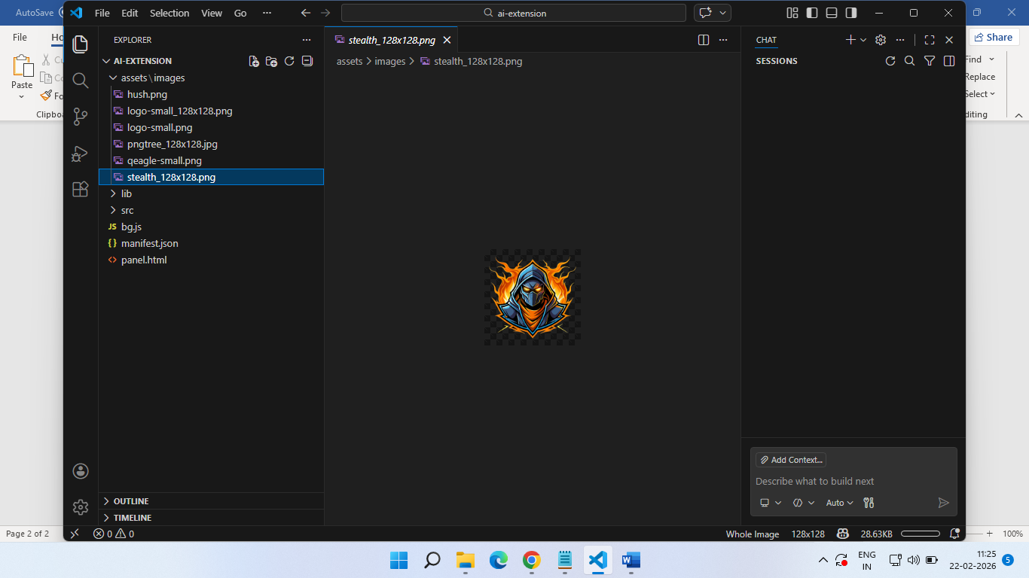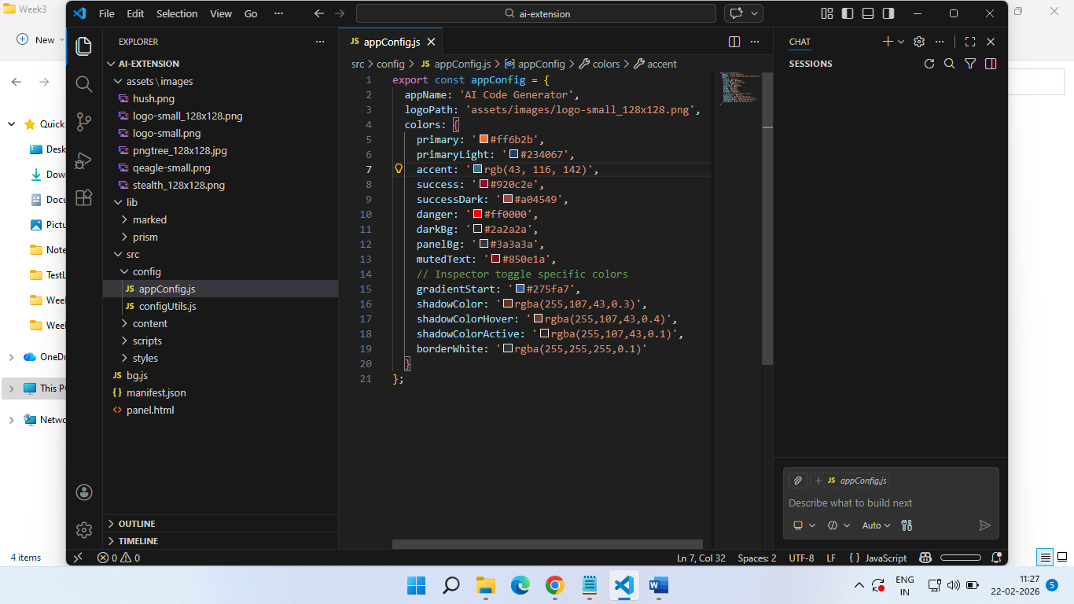qeagle-small.png not used however I tried to find using co-pilot 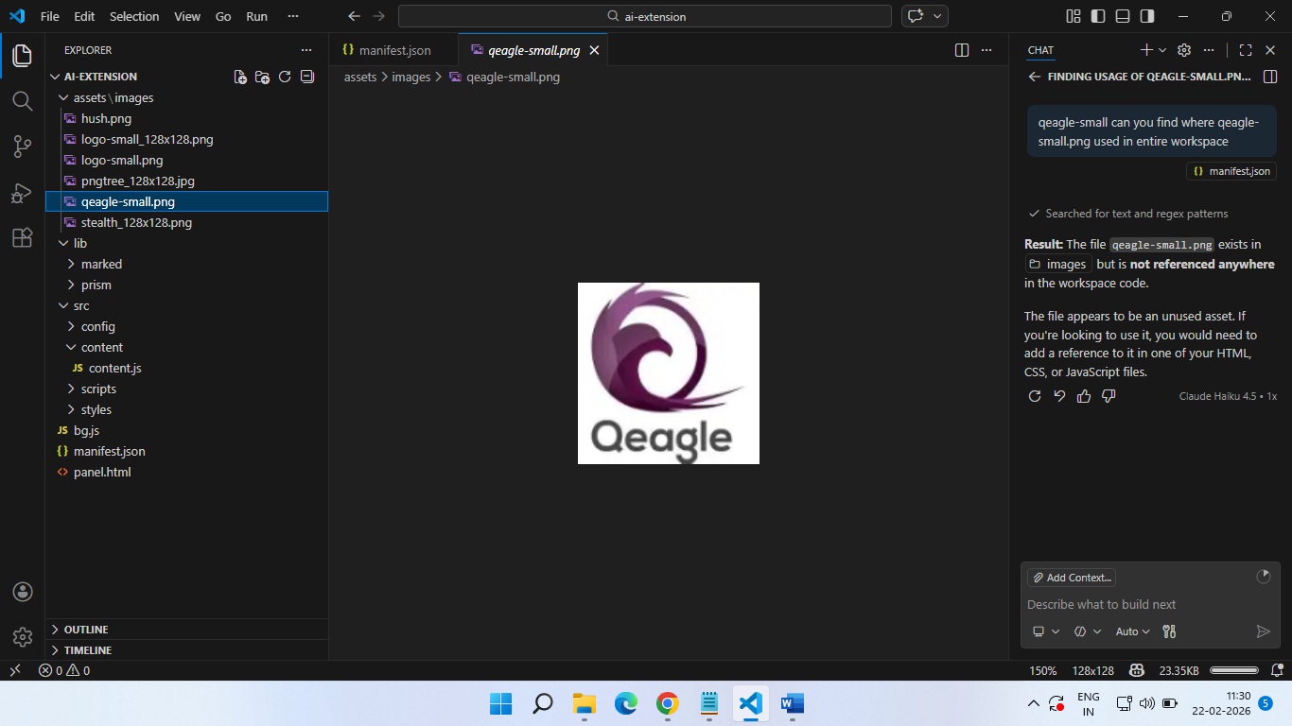adding plugin to the browser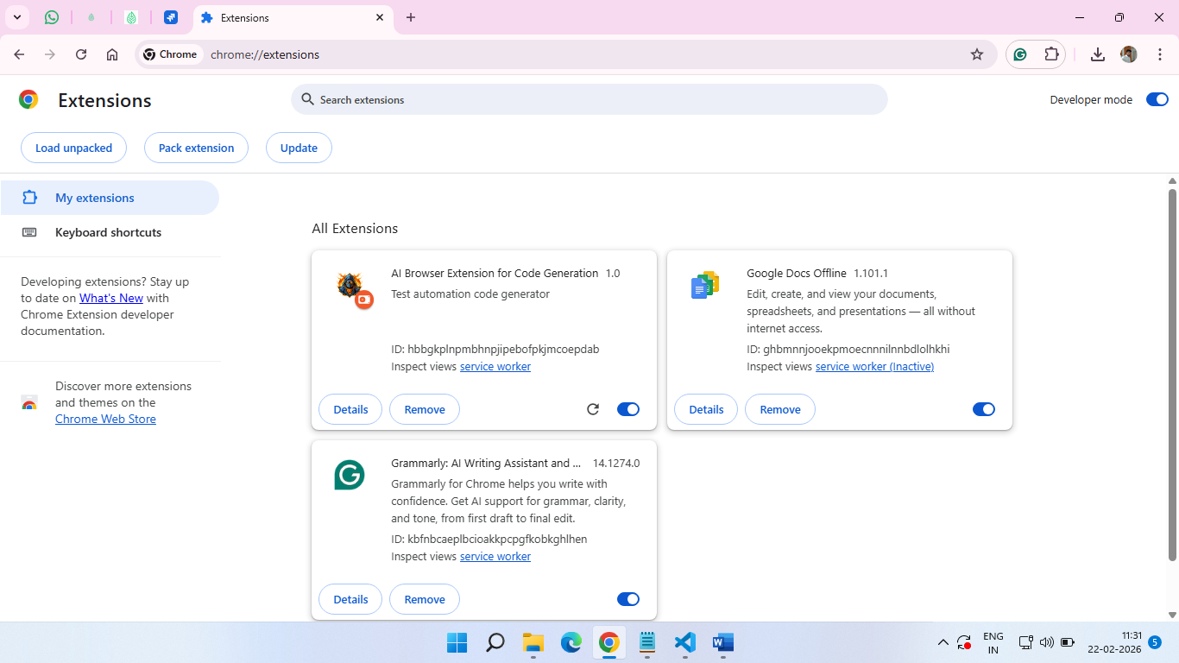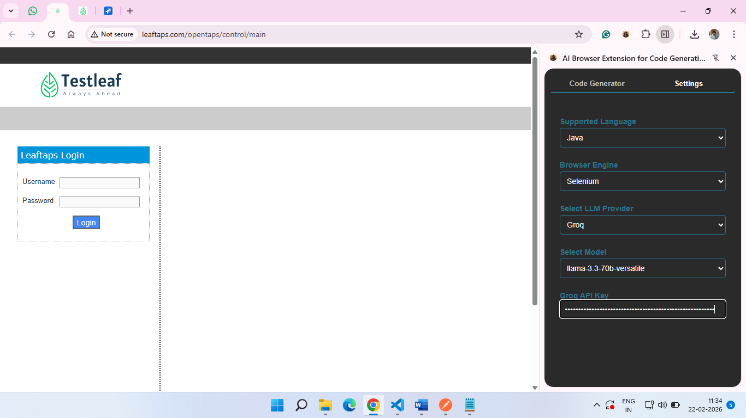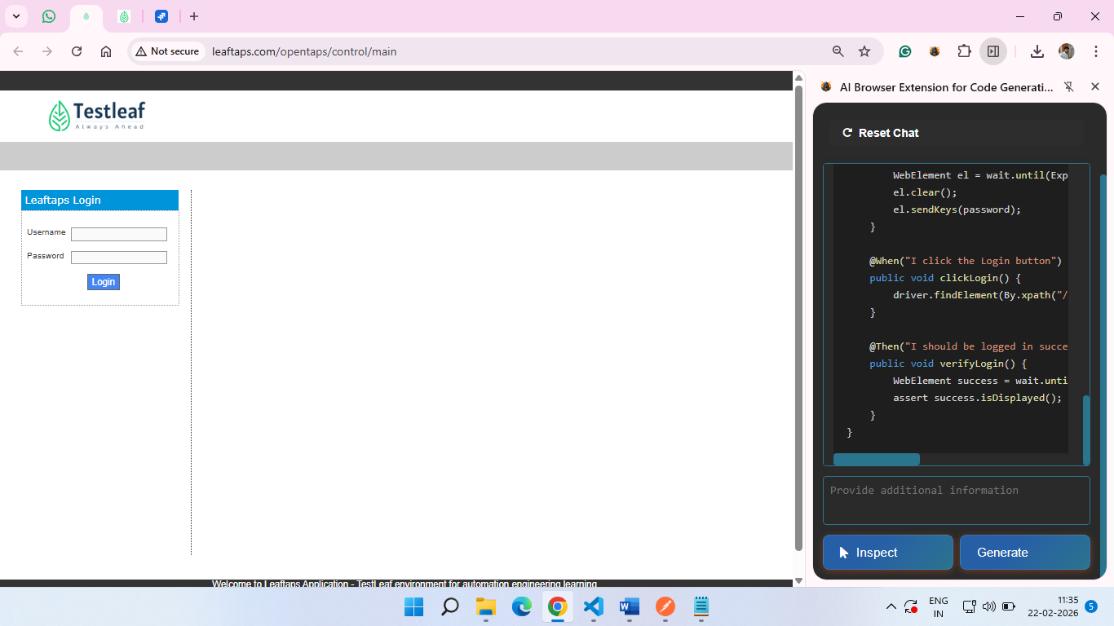Feature: Login to OpenTaps

Scenario Outline: Successful login with valid credentials

Given I open the login page

When I type "<username>" into the Username field

And I type "<password>" into the Password field

And I click the Login button

Then I should be logged in successfully

Examples:

| username | password |

| "demosalesmanager" | "crmsfa"|

| "demomarketinguser" | "crmsfa"|

| "demopurchaseuser" | "crmsfa"|

package com.leaftaps.stepdefs;

import io.cucumber.java.en.\*;

import org.openqa.selenium.\*;

import org.openqa.selenium.chrome.ChromeDriver;

import org.openqa.selenium.support.ui.\*;

public class LoginStepDefinitions {

private WebDriver driver;

private WebDriverWait wait;

@io.cucumber.java.Before

public void setUp() {

System.setProperty("webdriver.chrome.driver", "/path/to/chromedriver");

driver = new ChromeDriver();

wait = new WebDriverWait(driver, java.time.Duration.ofSeconds(10));

driver.manage().window().maximize();

}

@io.cucumber.java.After

public void tearDown() {

if (driver != null) driver.quit();

}

@Given("I open the login page")

public void openLoginPage() {

driver.get("http://leaftaps.com/opentaps/control/main");

}

@When("I type {string} into the Username field")

public void enterUsername(String username) {

WebElement el = wait.until(ExpectedConditions.elementToBeClickable(By.id("username")));

el.clear();

el.sendKeys(username);

}

@When("I type {string} into the Password field")

public void enterPassword(String password) {

WebElement el = wait.until(ExpectedConditions.elementToBeClickable(By.id("password")));

el.clear();

el.sendKeys(password);

}

@When("I click the Login button")

public void clickLogin() {

driver.findElement(By.xpath("//input[@class='decorativeSubmit']")).click();

}

@Then("I should be logged in successfully")

public void verifyLogin() {

WebElement success = wait.until(ExpectedConditions.visibilityOfElementLocated(By.tagName("h2")));

assert success.isDisplayed();

}

}

Logo changed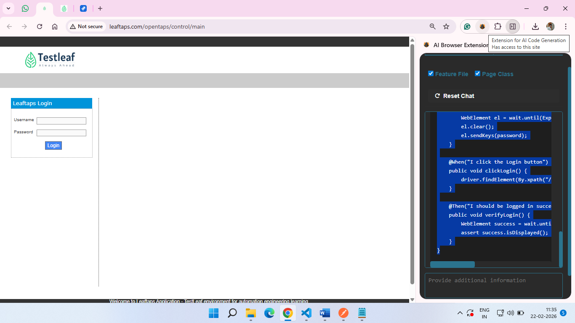 Home Assignments

1) Use Bugmagnet and Fake filler extension for form filling

2) Use grammarly extension to correct the mistakes in your content

3) Vibe Coding Generate Playwright Typescript 0r (any tool with language binding in which you are working)

1) Use Bugmagnet and Fake filler extension for form filling

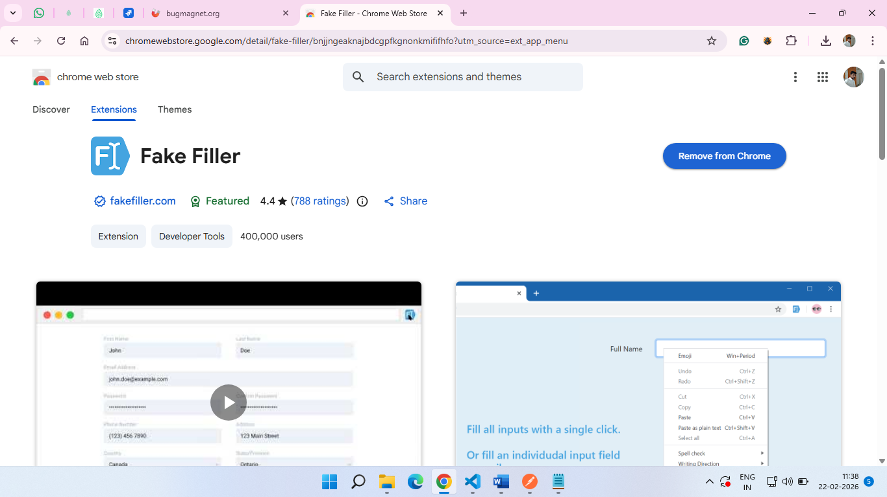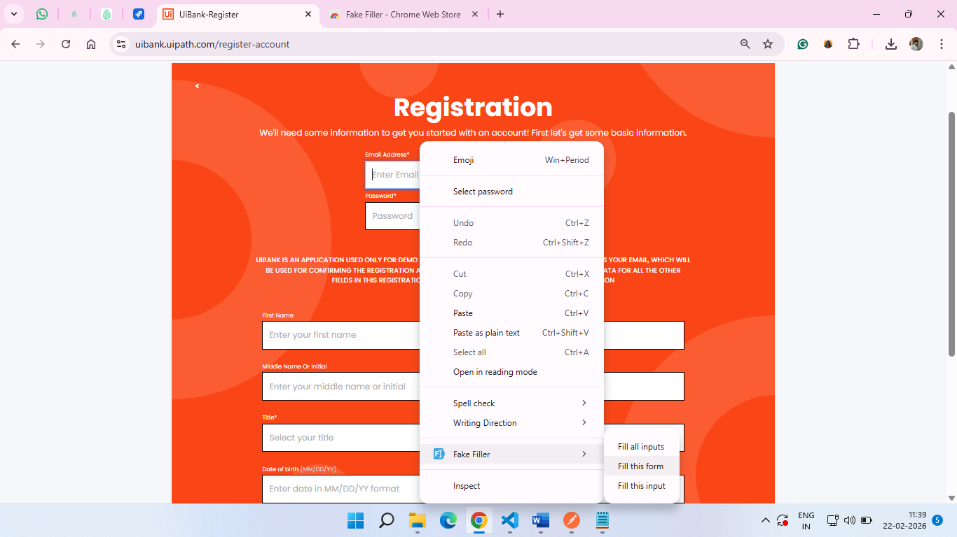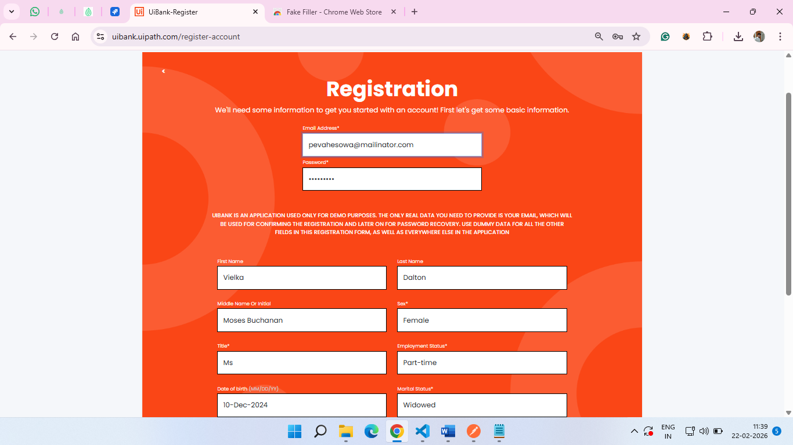2) Use grammarly extension to correct the mistakes in your content

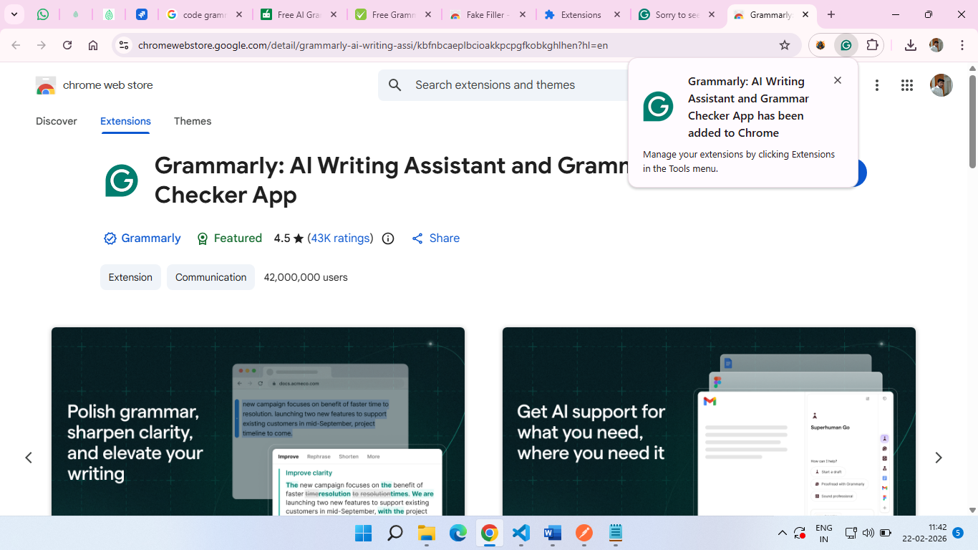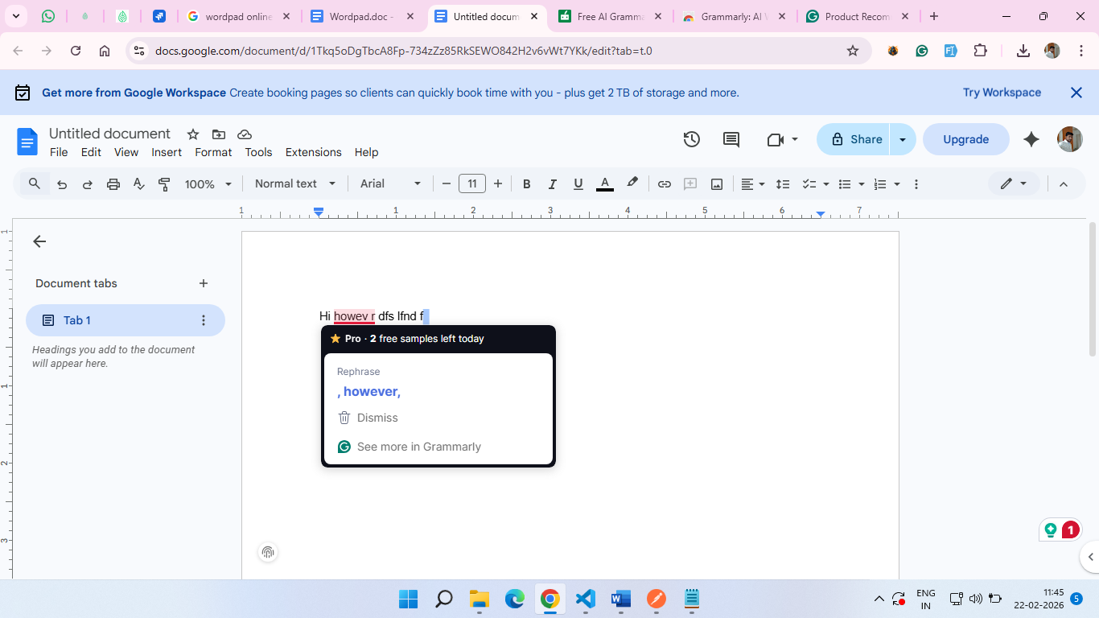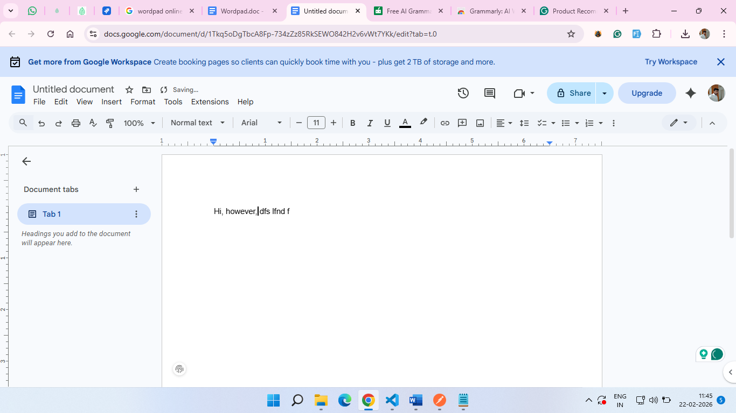3) Vibe Coding Generate Playwright Typescript 0r (any tool with language binding in which you are working) 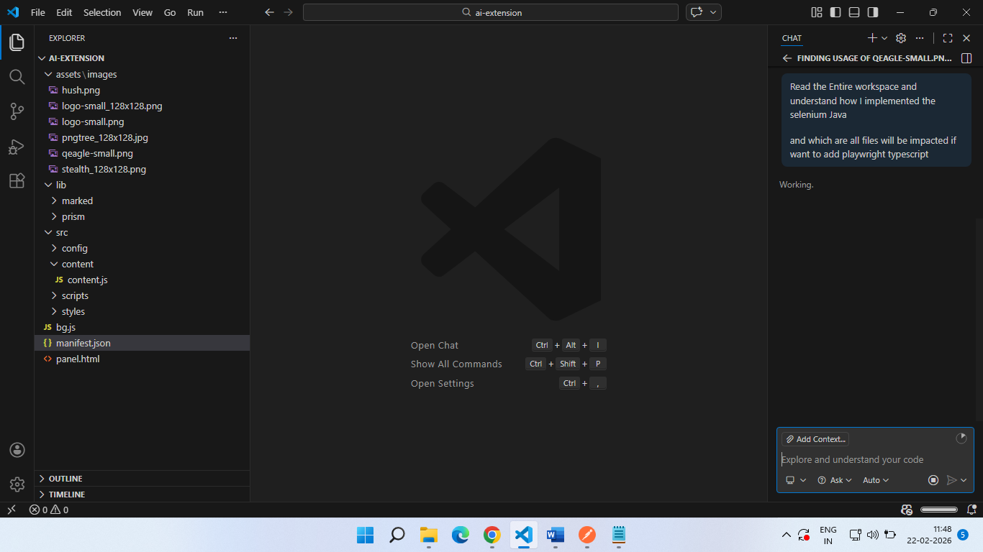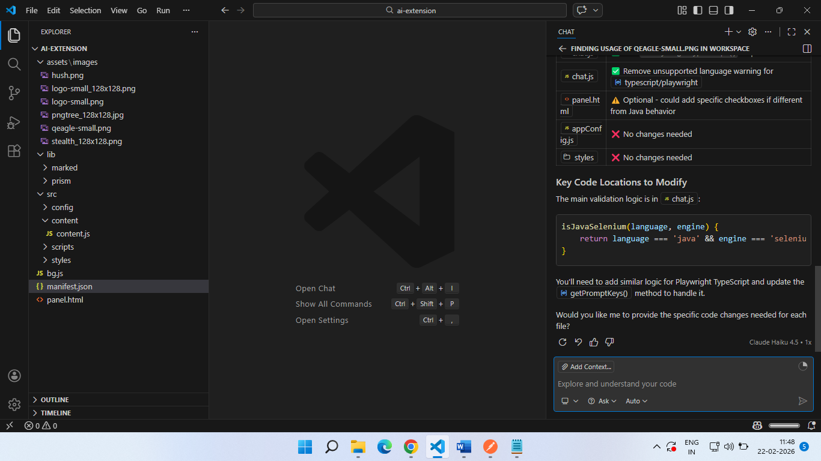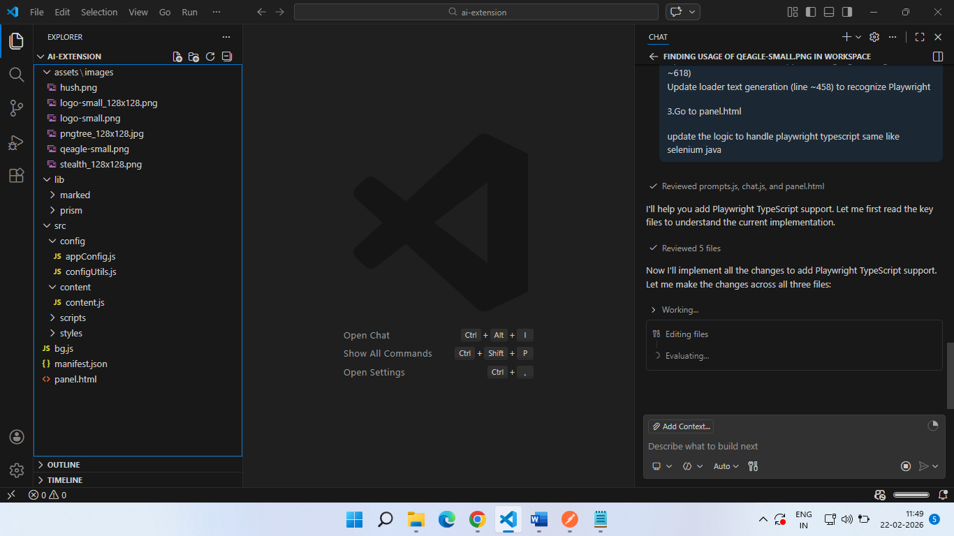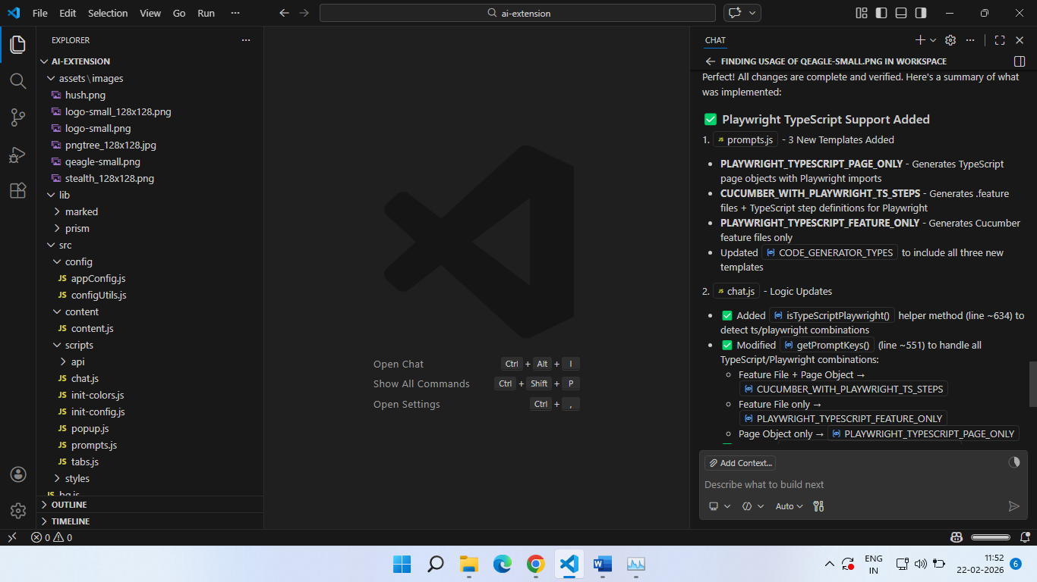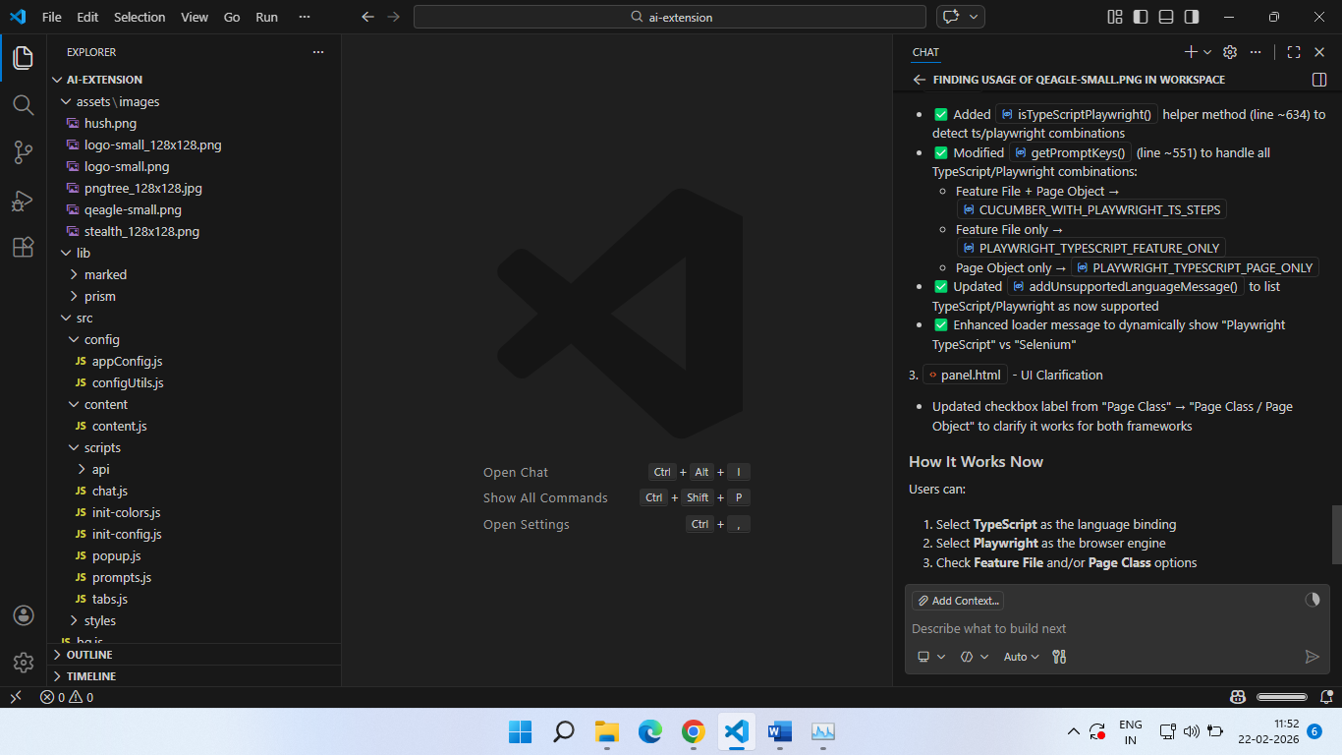Readded the extension:

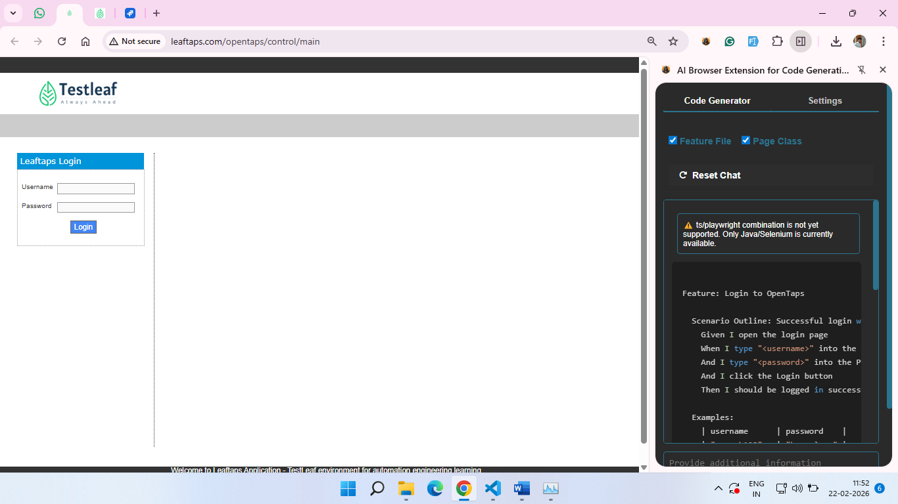copy button added additionally

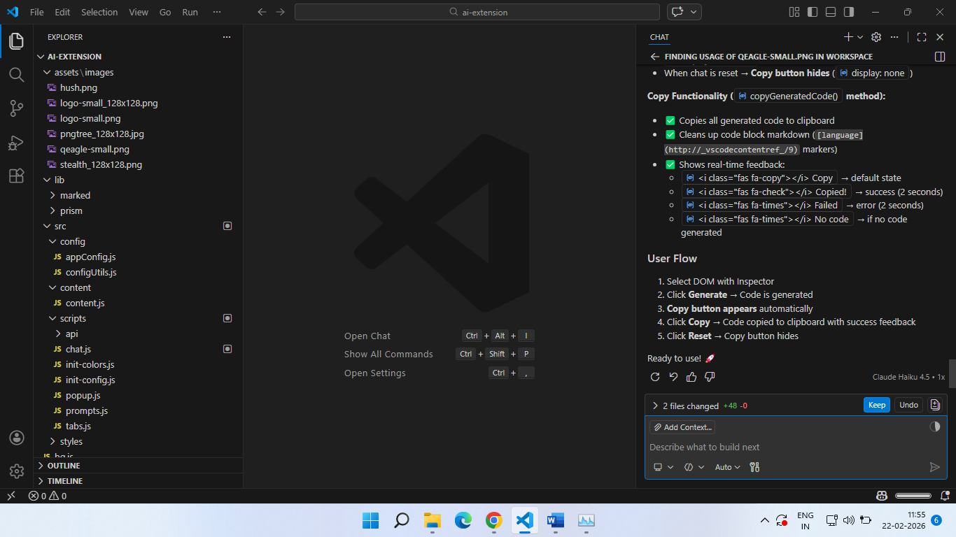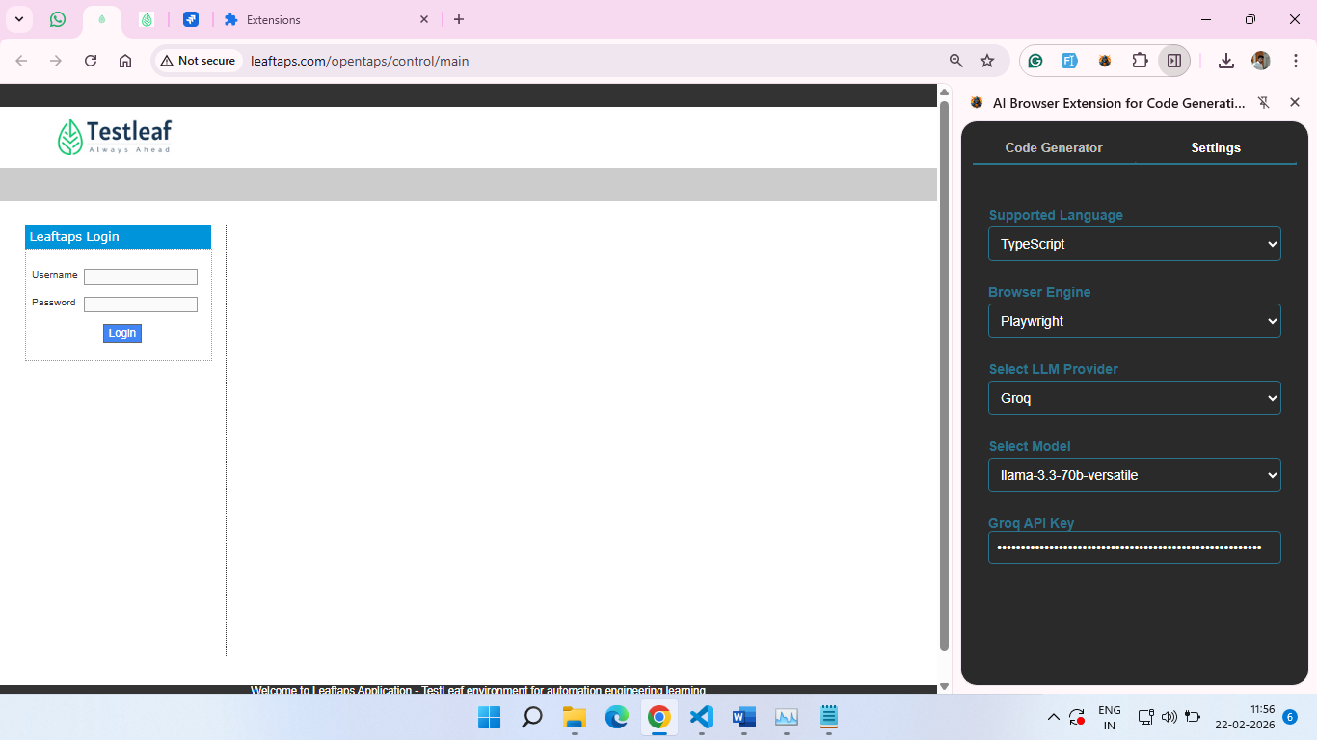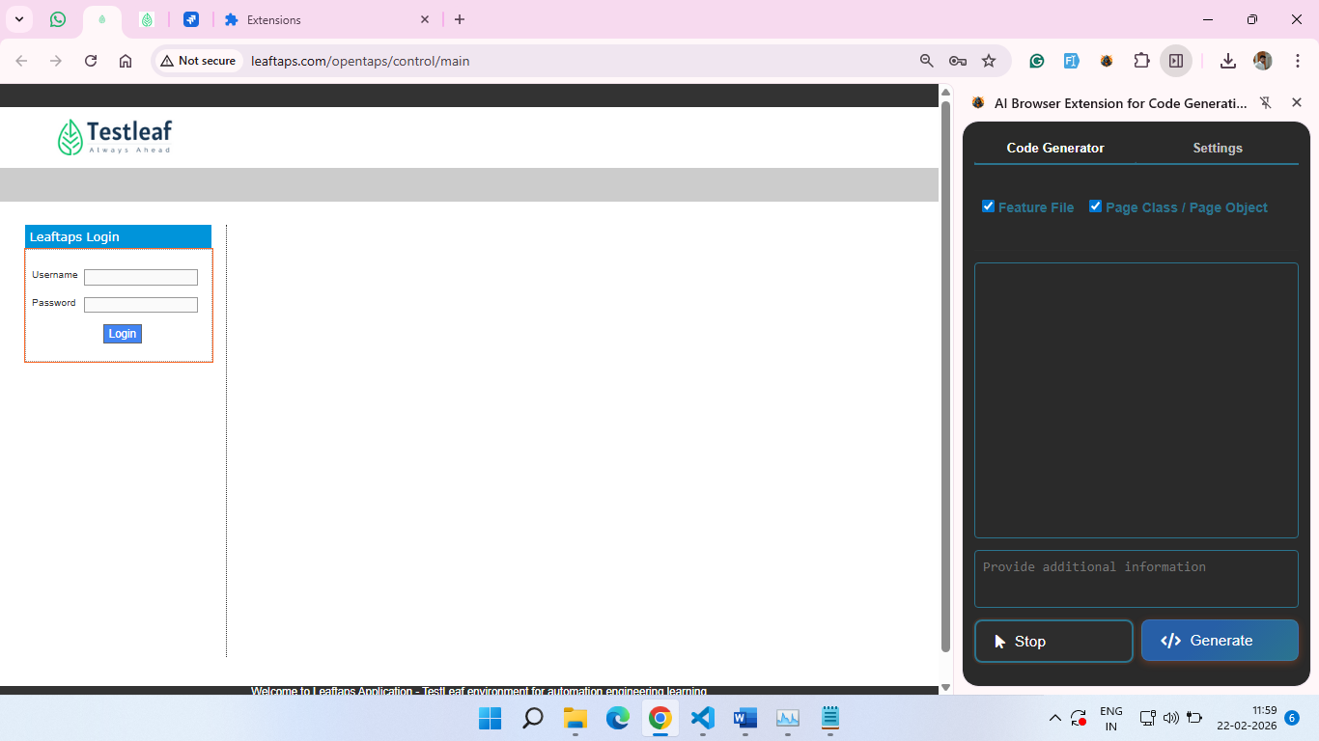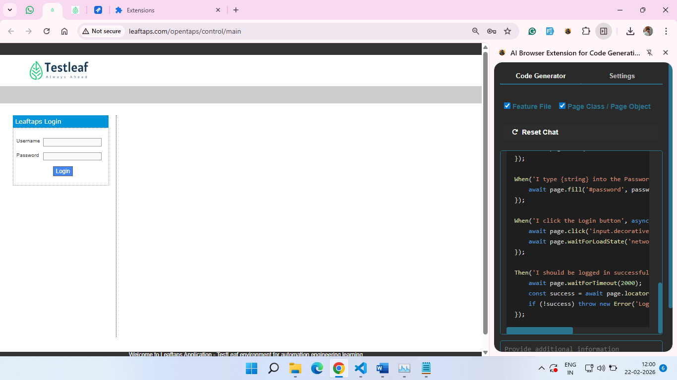Feature: Login to OpenTaps

Scenario Outline: Successful login with valid credentials

Given I open the login page

When I type "<username>" into the Username field

And I type "<password>" into the Password field

And I click the Login button

Then I should be logged in successfully

Examples:

| username | password |

| "demosalesmanager" | "crmsfa" |

| "demoadmin" | "demosalesmanager123"|

| "rajkumar" | "rajkumar123"|

import { Given, When, Then, Before, After } from '@cucumber/cucumber';

import { Browser, BrowserContext, Page, chromium } from 'playwright';

let browser: Browser;

let context: BrowserContext;

let page: Page;

Before(async function() {

browser = await chromium.launch({ headless: false });

context = await browser.newContext();

page = await context.newPage();

});

After(async function() {

await context.close();

await browser.close();

});

Given('I open the login page', async function() {

await page.goto('http://leaftaps.com/opentaps/control/main');

await page.waitForLoadState('networkidle');

});

When('I type {string} into the Username field', async function(username: string) {

await page.fill('#username', username);

});

When('I type {string} into the Password field', async function(password: string) {

await page.fill('#password', password);

});

When('I click the Login button', async function() {

await page.click('input.decorativeSubmit');

await page.waitForLoadState('networkidle');

});

Then('I should be logged in successfully', async function() {

await page.waitForTimeout(2000);

const success = await page.locator('#header').isVisible();

if (!success) throw new Error('Login failed');

});

Uploaded full project in repo